* 🡪 HTML
  + doc
  + h1: header
    - ID: title
    - On main.css🡪 #title{
      * color:red;
      * copy and paste into line 7:
        + <link rel="stylesheet"href="main.css">
  + p: text
  + h3: smaller header
* 🡪sketch.js
* 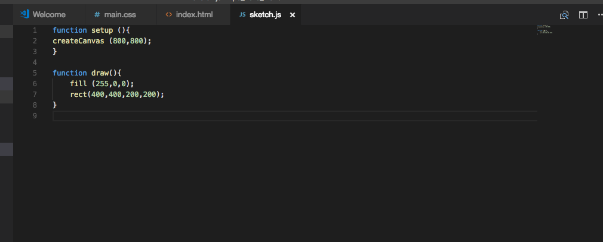
  + Makes red rectangle